6.7 DAX calculation groups, dynamic format strings and field parameters

Calculation Groups
Calculation groups are a simple way to reduce the number of measures in a model by grouping common measure expressions. Calculation groups work with existing explicit DAX measures by automating repetitive patterns.
Calculation Groups can be created in Power BI Desktop & also Tabular Editor.
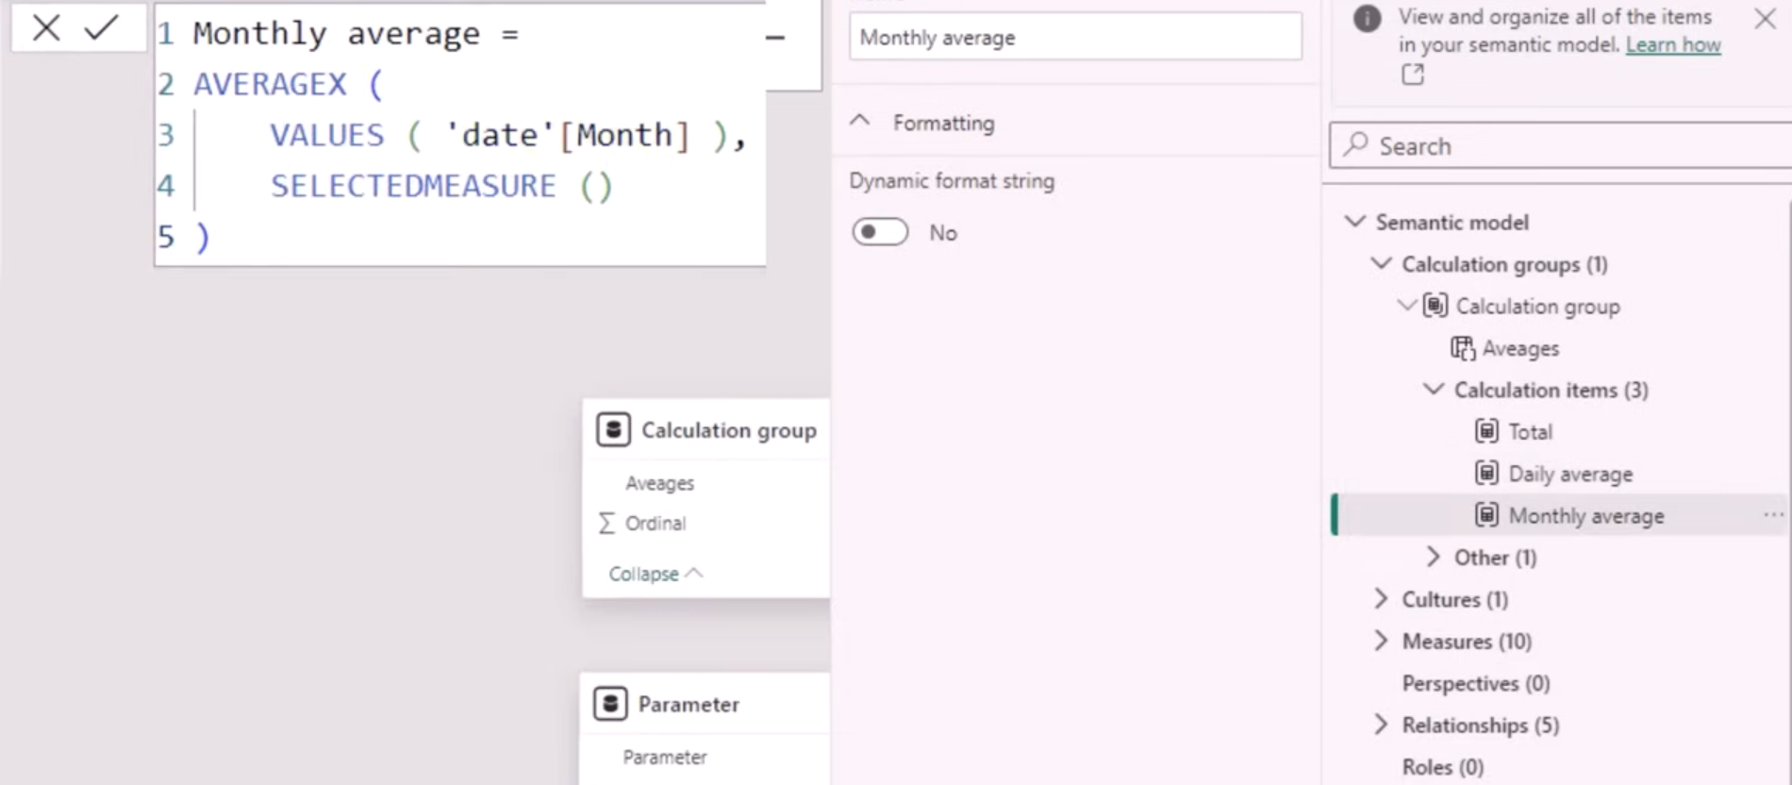

Dynamic Strings
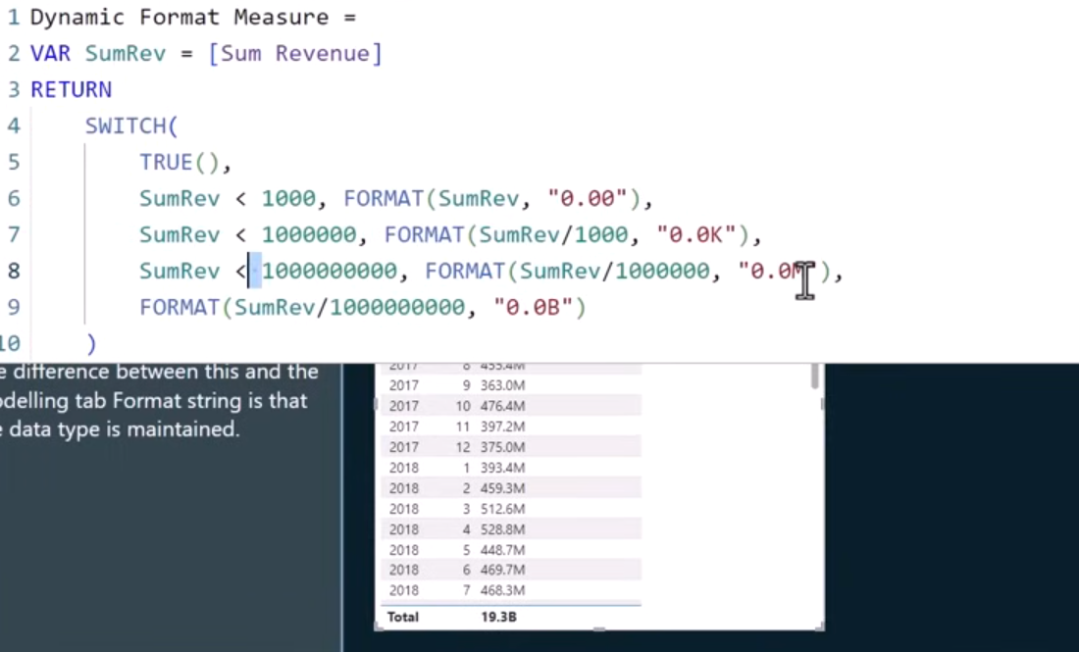
Dynamic format strings - With dynamic format strings for measures, you can determine how measures appear in visuals by conditionally applying a format string with a separate DAX expression.

Field parameters
Field parameters allow the report user to select a categoric variable to view a particular measure by.
In this example, we've used field parameters to show Revenue by either Location, Dealer, Country, Model, Product.
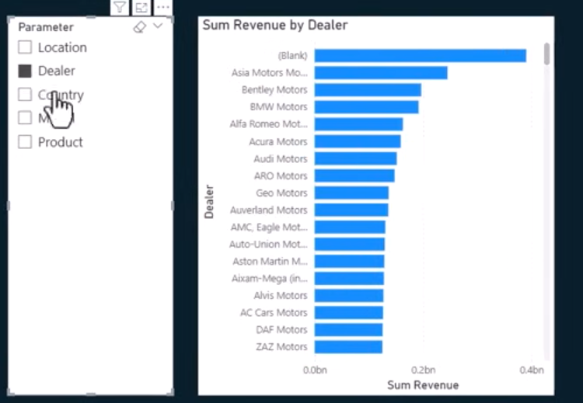

Summary
- Calculation groups = model optimization & maintainability
- Dynamic format strings = visual formatting only (not values)
- Field parameters = report-level interactivity

